**2. System Archtecture**

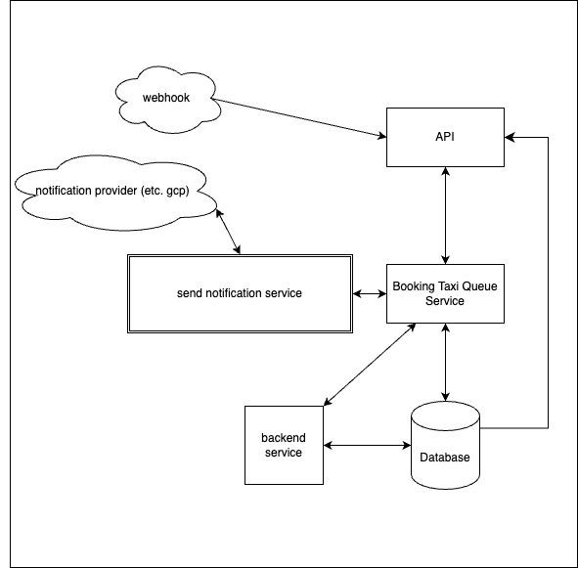

**API Service** - This is a RESTful API. When a user requests information or receives data from a parking webhook (e.g., new taxi booking, taxi booking history), it will communicate with the taxi queue service and the database to provide information to the user.

**Booking Taxi Queue Service** - This service manages the booking queue upon receiving data from the API Service. If a notification needs to be sent to the user, it will send the notification details to the notification service. This service may utilize a message broker for management.

**Notification Service** - This is a notification management system that receives data from the Booking Taxi Queue Service. It manages the notification queue and forwards it to the notification provider (e.g., GCP) so that the provider can send the notification to the user's device. It also handles resending notifications in case of issues.

**Backend Service** - This system manages users, taxis, and drivers by storing information in the database. This includes fetching the next queue item, canceling bookings, and sending data to the booking taxi queue service.

**Database** - This is the database for users, taxi bookings, and notifications. It receives data from the API and the managed queue system.